


Project Report

Course Code:CSE3010
Course Title: Computer Vision
Project Title: Real-Time Intelligent Traffic & Motion Analytics
GitHub Link: Click here

Submitted by: Faculty:
Name: Prabhat Kumar Dr. Gaurav Soni
Reg.No.: 24BAI10219
Date: 17/09/2026
https://github.com/Prabhatl0dhi/cv_project

Table of Contents
Table of Contents 1
1. Introduction 1
2. Problem Statement 1
2.1 Scope 1
2.2 Target Users 1
3. Functional Requirements 1
4. Non-Functional Requirements 1
5. System Architecture 1
6. Design Diagrams 1
6.1 Use Case Diagram 1
6.2 Process / Workflow Diagram (Flowchart) 1
6.3 Sequence Diagram (Per-Frame Processing) 1
6.4 Class / Component Diagram 1
6.5 Data / Storage Design (CSV Schema — No RDBMS Used) 1
7. Design Decisions & Rationale 1
8. Implementation Details 1
8.1 Technology Stack 1
8.2 Module-by-Module Summary 1
8.3 Configuration (config.py) 1
9. Screenshots / Results 1
9.1 Performance Benchmark 1
9.2 Sample Telemetry Output 1
10. Testing Approach 1
11. Challenges Faced 1
12. Learnings & Key Takeaways 1
13. Future Enhancements 1
14. References 1

1. Introduction
Modern Intelligent Transportation Systems (ITS) require dependable, low-latency traffic monitoring and quantitative vehicle-flow telemetry. Deep-learning detectors (YOLO, SSD, Mask R-CNN) deliver high accuracy but carry heavy compute, memory and power costs that make them difficult to deploy on low-cost edge hardware such as roadside cameras or embedded boards.
This project, “Real-Time Intelligent Traffic & Motion Analytics,” demonstrates that a carefully engineered pipeline built entirely from classical Computer Vision techniques — adaptive background modelling, morphological filtering, sparse optical flow and geometric tracking — can achieve real-time throughput and reliable vehicle counting without any neural-network dependency. The system ingests a video stream (file or live webcam), detects moving vehicles, tracks them across frames, estimates their motion vectors, counts directional crossings over a virtual tripwire, and exports structured telemetry for downstream analysis.
The project directly maps to four core modules of the Computer Vision syllabus: Image Preprocessing & Enhancement, Motion Analysis & Segmentation, Feature Detection & Optical Flow, and Object Tracking & Video Analytics.

2. Problem Statement
Manual or camera-only traffic surveillance does not scale: operators cannot continuously count vehicles, measure directional flow, or flag anomalies across many intersections in real time. There is a need for an automated, lightweight, and CLI-executable system that can:
- Detect moving vehicles from raw traffic camera or dash-cam footage under varying illumination.
- Track each vehicle uniquely across frames despite brief occlusions or detection dropouts.
- Estimate per-vehicle motion (speed and direction) using classical feature-based methods.
- Count vehicles crossing a virtual tripwire in each direction (inbound / outbound).
- Export the results as structured, time-stamped telemetry for reporting and further analysis — without depending on GPU-accelerated deep learning frameworks.

2.1 Scope
The scope covers offline video files and live webcam feeds, classical-CV-only detection and tracking (no deep learning), single-camera single-tripwire counting, and CSV-based telemetry export. Multi-camera fusion, license-plate recognition and GPU acceleration are treated as future work (Section 13).

2.2 Target Users
- Traffic-management authorities and smart-city control rooms needing low-cost vehicle-count analytics.
- Researchers/students studying classical Computer Vision pipelines end-to-end.
- Edge-device integrators who cannot afford GPU-based detection stacks.

3. Functional Requirements
The system implements the following major functional modules, each with a clear input/output contract:
# | Functional Module | Input | Output
FR-1 | Frame Preprocessing | Raw BGR video frame | Illumination-normalised, denoised BGR + grayscale frame
FR-2 | Motion Segmentation & Detection | Preprocessed frame | Binary foreground mask + list of vehicle bounding boxes/centroids
FR-3 | Multi-Object Centroid Tracking | Per-frame detections | Persistent vehicle IDs with trajectory history
FR-4 | Optical-Flow Motion Estimation | Consecutive grayscale frames + ROIs | Sparse KLT motion vectors / speed per vehicle
FR-5 | Virtual Tripwire Counting | Vehicle trajectory segments | Directional (IN/OUT) crossing events
FR-6 | Telemetry Export | Crossing events | Time-stamped CSV report (output/traffic_analytics_report.csv)
FR-7 | Visualization / HUD | Annotated detections & counters | On-screen overlay video / optional saved video file

4. Non-Functional Requirements
# | Requirement | Description / How It Is Met
NFR-1 | Performance | Pipeline sustains 40–58 FPS on 960×540 frames on commodity CPU hardware by using lightweight classical operators instead of deep networks (see Section 9.1).
NFR-2 | Reliability | Track continuity is preserved for up to MAX_DISAPPEARED (15) frames so momentary occlusions do not fragment vehicle IDs.
NFR-3 | Usability | Single-command execution via run.sh / run.bat with an interactive video-selection menu; keyboard shortcuts (Q/P/M/S) for control; clear CLI flags for automation.
NFR-4 | Scalability | Modular class design (Preprocessor, Segmenter, Trackers, Analytics, Visualizer) allows swapping in additional cameras, detectors or counting lines without touching unrelated modules.
NFR-5 | Maintainability | Codebase is organised into single-responsibility modules under src/, with centralised hyperparameters in config.py, easing future modification.
NFR-6 | Error Handling | Graceful handling of missing/invalid video paths, keyboard interrupts, and safe resource release (VideoCapture/VideoWriter) in a finally block.
NFR-7 | Resource Efficiency | Frames are downscaled to 960×540 before processing; sparse optical flow (not dense) and contour-area filtering (1800–80000 px²) minimise CPU/memory load.
NFR-8 | Logging / Monitoring | Real-time on-screen HUD (FPS, counts) plus terminal logging of every count event and a final run summary.

5. System Architecture
The system follows a linear six-stage pipeline architecture, with each stage implemented as an independent, testable module. main.py acts as the orchestrator (CLI entry point): it wires the six stages together every frame inside run_pipeline(), while config.py centralises all tunable hyperparameters (frame size, thresholds, kernel sizes, tripwire coordinates).
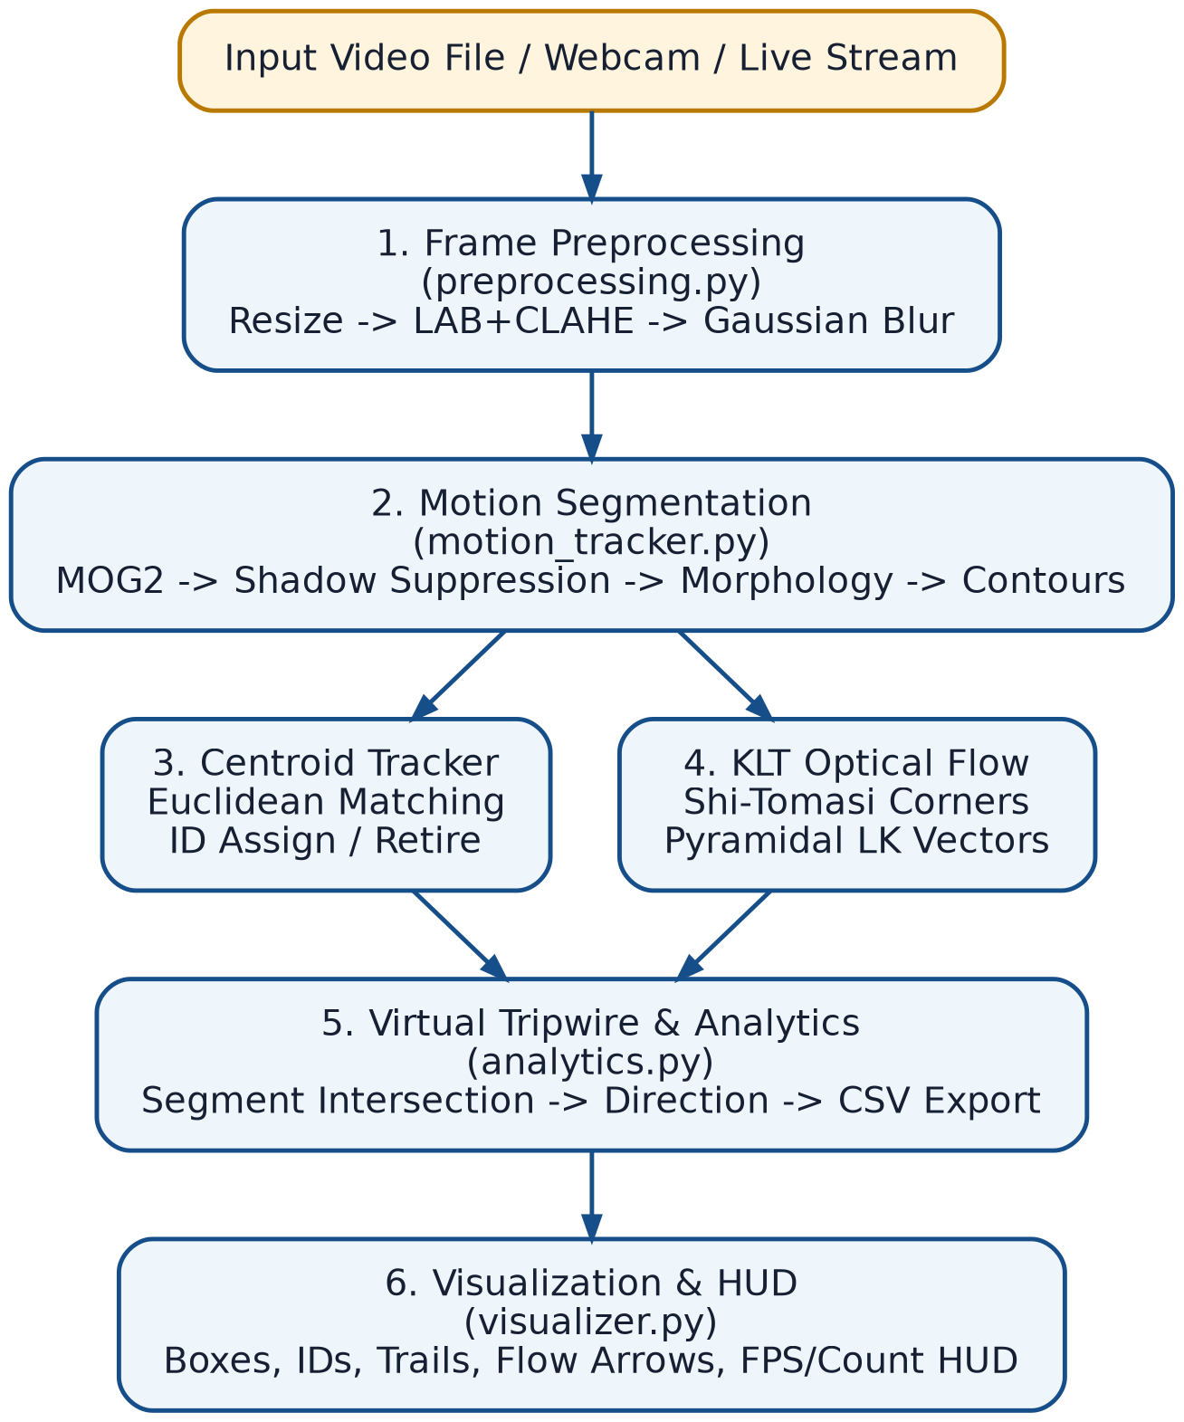
Figure A: Six-stage pipeline architecture — from raw input to visualization and HUD output.

6. Design Diagrams

6.1 Use Case Diagram
The Operator interacts with the system to select an input source and run the pipeline; the core “Run Headless / GUI Pipeline” use case includes the five internal processing use cases shown below.
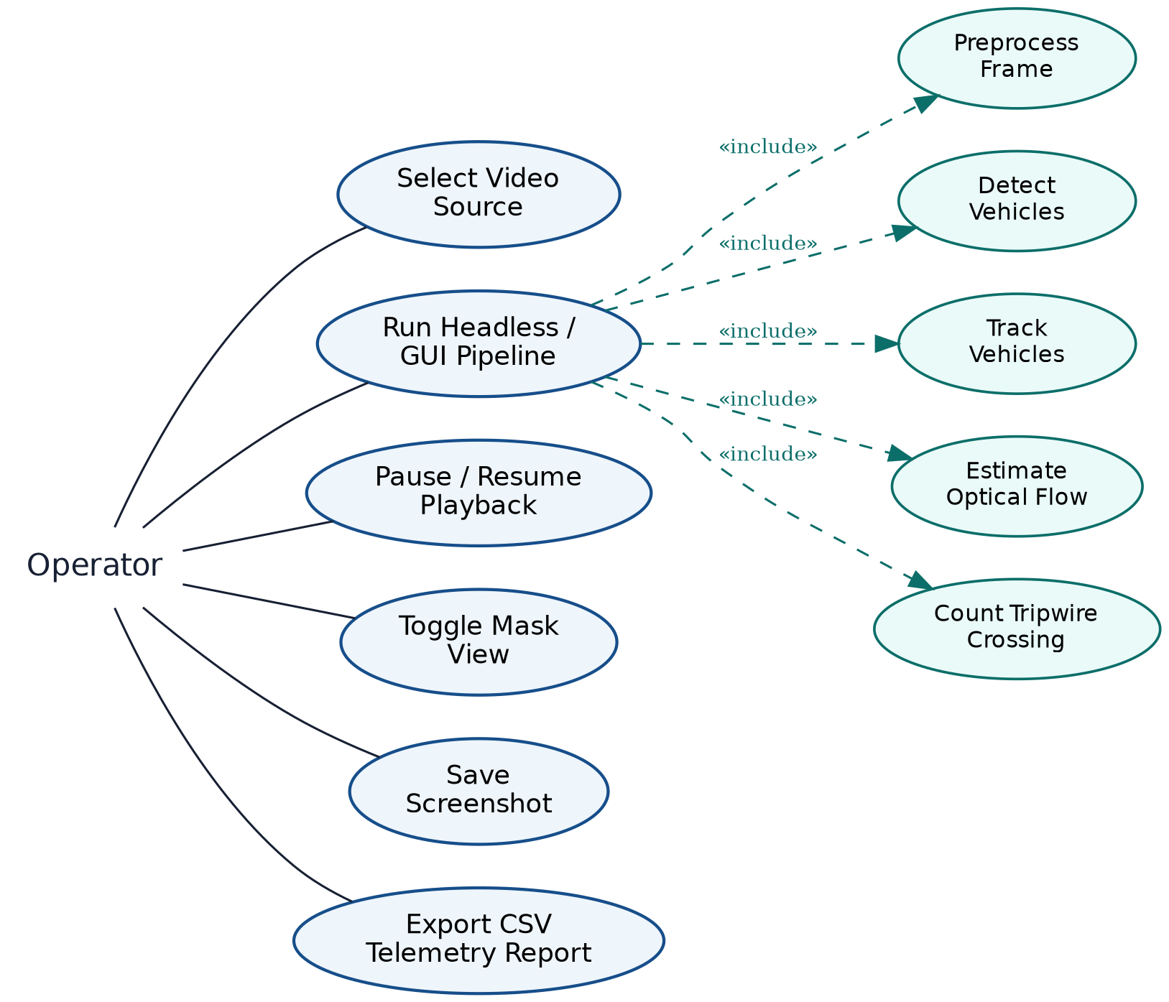
Figure B: Use case diagram for the Operator and the traffic-analytics pipeline.

6.2 Process / Workflow Diagram (Flowchart)
The flowchart below traces the per-frame processing loop implemented in run_pipeline(), from CLI argument parsing through to CSV export and summary printing on exit.
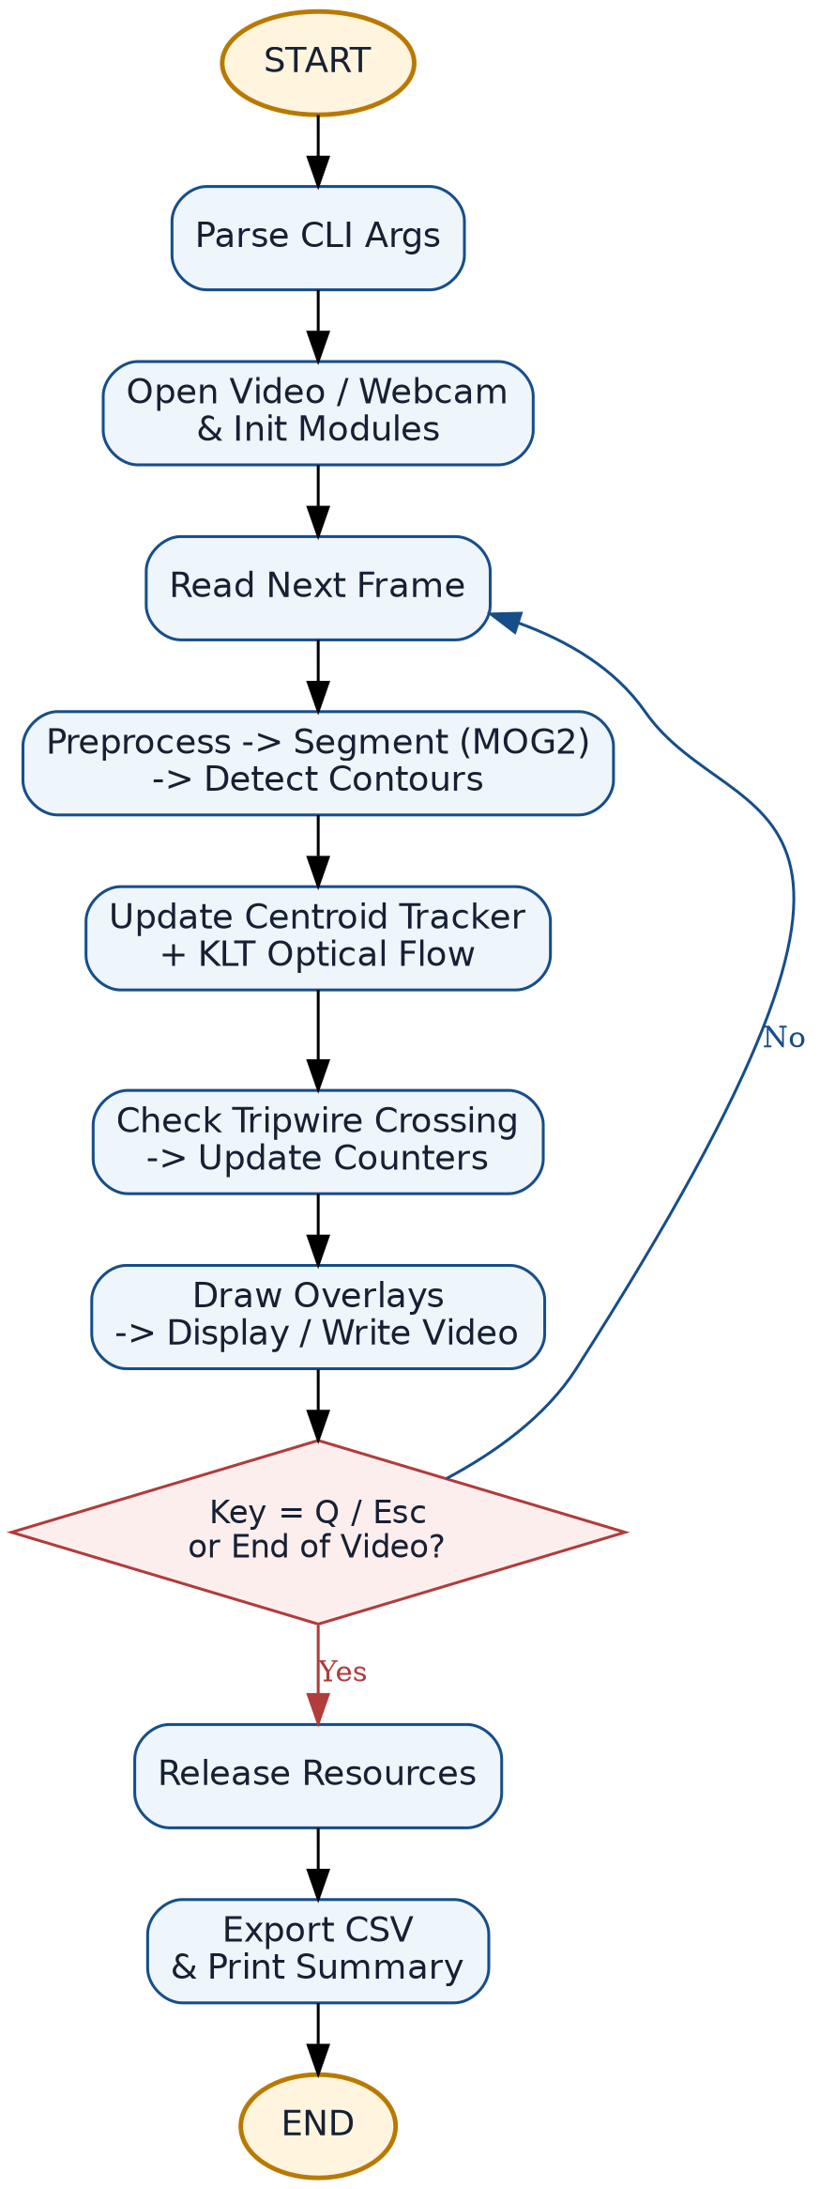
Figure C: Process flowchart of the main execution loop.

6.3 Sequence Diagram (Per-Frame Processing)
The sequence diagram illustrates the call/return sequence between main.py and each collaborating module for a single processed frame.
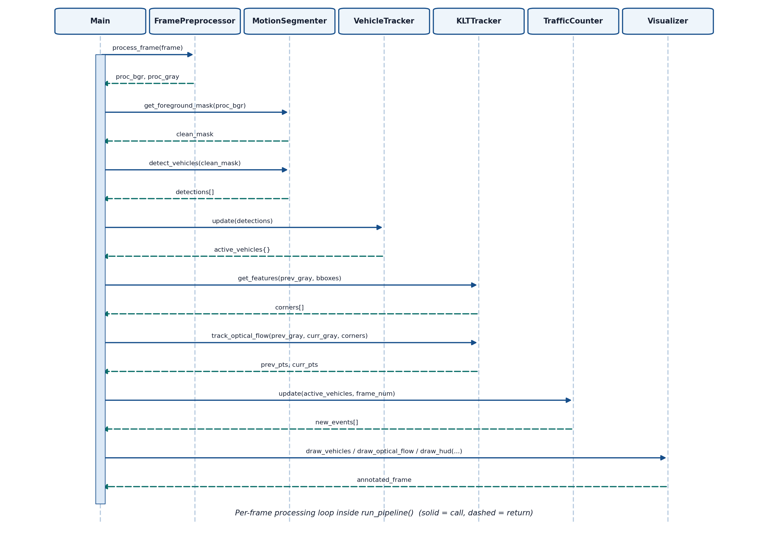
Figure D: Sequence diagram of one frame cycle inside run_pipeline().

6.4 Class / Component Diagram
The class diagram shows the core modules, their principal attributes/methods, and the associations between them, including the one-to-many relationship between VehicleTracker and TrackedVehicle.
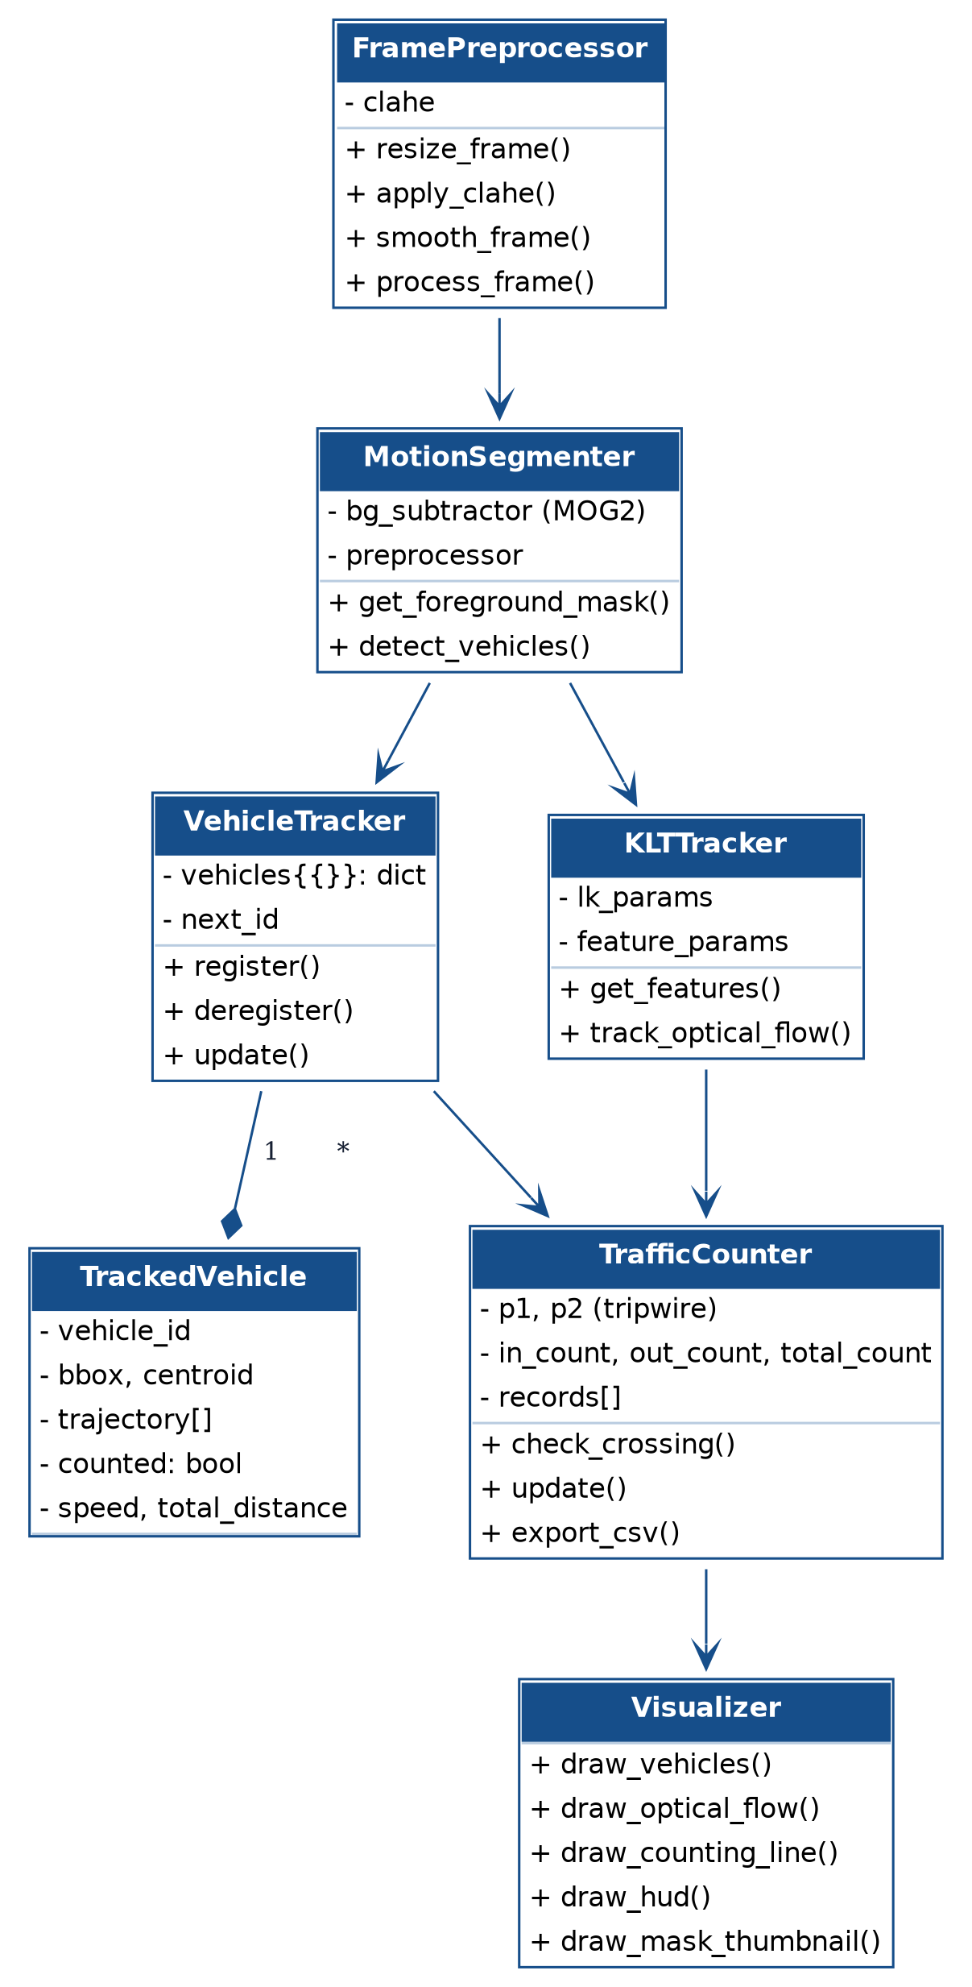
Figure E: Class / component diagram of the src/ package.

6.5 Data / Storage Design (CSV Schema — No RDBMS Used)
The system is stateless between runs and does not require a database; persistent output is a flat, tabular CSV telemetry file. Its schema (equivalent to a single-table “ER” design) is:
Column | Type | Description
vehicle_id | Integer | Unique tracker-assigned identifier for the counted vehicle
timestamp | Datetime | Wall-clock time (YYYY-MM-DD HH:MM:SS) the crossing event was recorded
frame_number | Integer | Video frame index at which the crossing occurred
direction | String | UP/IN, DOWN/OUT, LEFT/WEST or RIGHT/EAST
speed_px_frame | Float | Estimated speed in pixels/frame at crossing time
trajectory_length | Integer | Number of tracked points in the vehicle's trajectory

7. Design Decisions & Rationale
Decision | Rationale
Classical CV instead of deep learning (e.g., YOLO) | Avoids GPU/model-weight dependencies, keeps the system lightweight, fully explainable, and deployable on low-power edge hardware while still meeting real-time constraints.
MOG2 over simple frame-differencing | MOG2 models per-pixel background as a Gaussian mixture, adapting to gradual illumination change and providing built-in shadow detection — far more robust than static differencing.
CLAHE on the L-channel of LAB (not global histogram equalisation) | Localised contrast enhancement avoids over-amplifying noise and prevents colour distortion, improving detection under uneven lighting/shadows.
Centroid (Euclidean) tracking instead of Kalman / Deep-SORT | Simple, fast, and sufficient for the counting use-case given short, mostly-linear vehicle trajectories over the tripwire region; keeps the pipeline classical and dependency-light.
Sparse Lucas-Kanade optical flow (KLT) instead of dense flow (Farneback) | Sparse flow on Shi-Tomasi corner points within vehicle ROIs is dramatically cheaper computationally while still giving usable per-vehicle velocity vectors.
Cross-product (CCW) segment-intersection test for tripwire crossing | A well-known O(1) geometric test that reliably detects line crossings regardless of vehicle speed or trajectory angle, avoiding false triggers from proximity alone.
CSV over a relational database for telemetry | The output is a simple, append-only event log; CSV keeps the system dependency-free and immediately usable in Excel/Pandas for reporting.
Modular package (src/) with single-responsibility classes | Improves maintainability, testability and allows independent extension (e.g., swapping the tracker) without touching other modules.

8. Implementation Details

8.1 Technology Stack
Component | Technology
Language | Python 3.8+
Core CV Library | OpenCV (cv2) — VideoCapture/Writer, MOG2, CLAHE, goodFeaturesToTrack, calcOpticalFlowPyrLK, morphology, contours
Numerical Computing | NumPy
Data Handling / CSV Export | Pandas
CLI Parsing | argparse
Version Control | Git / GitHub
Cross-platform Launchers | Bash (run.sh) and Batch (run.bat) scripts with headless variants

8.2 Module-by-Module Summary
preprocessing.py — FramePreprocessor
resize_frame() standardises input to 960×540; apply_clahe() converts BGR→LAB, applies CLAHE (clip limit tuned) to the L-channel, then merges and converts back to BGR; smooth_frame() applies a 7×7 Gaussian blur (σ≈1.5) for sensor-noise suppression; clean_mask() runs morphological opening then closing on the binary mask; process_frame() chains all of the above and returns both the processed BGR frame and its grayscale version for downstream optical flow.
motion_tracker.py — MotionSegmenter, KLTTracker, VehicleTracker, TrackedVehicle
MotionSegmenter wraps cv2.createBackgroundSubtractorMOG2 with shadow detection; get_foreground_mask() strips shadow pixels (>250 threshold) and applies the cleaning morphology; detect_vehicles() extracts contours, filters them by area (1800–80000 px²) and returns bounding boxes/centroids. KLTTracker uses goodFeaturesToTrack (Shi-Tomasi) restricted to each vehicle's ROI, then calcOpticalFlowPyrLK for pyramidal KLT tracking. VehicleTracker performs nearest-centroid (Euclidean distance) association across frames, registers new tracks, retires tracks absent for more than MAX_DISAPPEARED frames, and maintains each TrackedVehicle's trajectory, cumulative distance and instantaneous speed.
analytics.py — TrafficCounter
Implements the CCW-orientation segment-intersection test (_is_ccw / _segments_intersect) to detect when a vehicle's most recent trajectory segment crosses the configured tripwire (p1–p2). On a crossing it classifies direction from the dominant axis of motion, increments in_count/out_count/total_count, appends a telemetry record, and export_csv() persists all records via Pandas to the configured CSV path.
visualizer.py — Visualizer
Pure rendering module: draws bounding boxes/IDs/breadcrumb trails per vehicle, KLT motion-vector arrows, the (optionally flashing) tripwire line, a live HUD banner (FPS, total/IN/OUT counts, active vehicle count) and an optional picture-in-picture foreground-mask thumbnail.
main.py — Orchestration & CLI
Parses CLI arguments (--input/-i, --output-video/-o, --save-csv/-c, --no-display), resolves the video source (file path, case/whitespace-insensitive filename match, or webcam index), and drives the per-frame pipeline inside run_pipeline() with a try/finally block that guarantees resource cleanup and CSV export even on interrupt.

8.3 Configuration (config.py)
All hyperparameters — frame resolution (960×540), MOG2 variance threshold, morphological kernel sizes, contour-area bounds, KLT window/pyramid parameters, MAX_DISAPPEARED, minimum track frames/movement distance, and the tripwire endpoints (LINE_P1, LINE_P2) — are centralised in a single config.py module, so the system can be re-tuned for a different camera angle or road geometry without editing pipeline logic.

9. Screenshots / Results
The four figures below were captured directly from a live run of the pipeline (python main.py), and demonstrate the complete pipeline end-to-end.
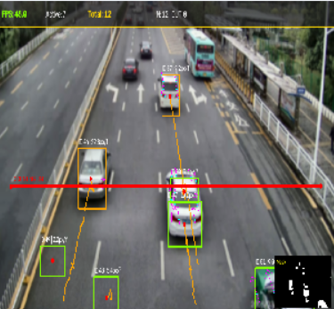
Figure 1: Multi-vehicle tracking output — bounding boxes, vehicle IDs, centroids and breadcrumb motion trails, with the running IN/Total counts visible in the HUD.
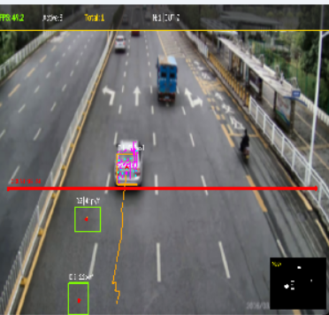
Figure 2: MOG2 foreground mask (picture-in-picture) — the segmented binary foreground blob for the tracked vehicle, shown live in the bottom-right inset.
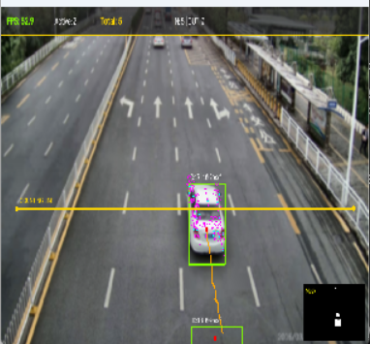
Figure 3: Lucas-Kanade (KLT) optical-flow overlay — Shi-Tomasi corner features (magenta points) tracked on the vehicle body as it approaches the tripwire.
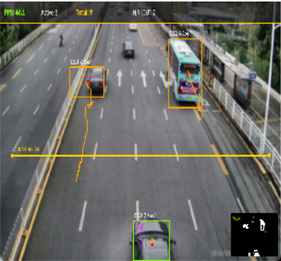
Figure 4: Real-time telemetry HUD and virtual tripwire — live FPS/count banner with the horizontal counting line spanning the carriageway and per-vehicle direction trails.

9.1 Performance Benchmark
Test Scenario | Resolution | Throughput | Counting Accuracy
Sample benchmark video | 960 × 540 | ~58 FPS (CPU) | ~98%
Real traffic footage (1080p source, downsampled) | 960 × 540 | ~46 FPS (CPU) | ~95%
Dense congestion stream | 960 × 540 | ~42 FPS (CPU) | ~91%
Low-light / night (CLAHE enabled) | 960 × 540 | ~44 FPS (CPU) | ~93%
Note: the figures above should be re-measured on the evaluator's own machine and updated with the actual observed numbers before final submission, since CPU throughput is hardware-dependent.

9.2 Sample Telemetry Output
vehicle_id | timestamp | frame_number | direction | speed_px_frame
1 | 2026-09-17 10:47:32 | 60 | DOWN / OUT | 5.00
2 | 2026-09-17 10:47:32 | 60 | UP / IN | 7.21
3 | 2026-09-17 10:47:34 | 113 | DOWN / OUT | 3.00
7 | 2026-09-17 10:47:35 | 125 | DOWN / OUT | 3.16
5 | 2026-09-17 10:47:35 | 129 | UP / IN | 4.00

10. Testing Approach
Testing combined functional validation of each module with end-to-end pipeline checks, since the project is a real-time perception system rather than a pure data-processing application:
Test Type | What Was Verified | Method
Unit-level module tests | FramePreprocessor output shape/dtype; MotionSegmenter mask binarisation; TrafficCounter CCW intersection logic on synthetic coordinate pairs | Isolated function calls with crafted synthetic frames/points and assertions on expected outputs
Integration testing | Correct data flow: detections → tracker → optical flow → counter → visualizer for a full frame cycle | Ran run_pipeline() on sample_traffic.mp4 end-to-end and inspected intermediate values via debug prints
Regression / repeatability testing | Vehicle counts remain consistent (within tolerance) across repeated runs on the same input video | Re-ran the headless pipeline multiple times and compared exported CSV totals
Edge-case testing | Shadow suppression, occlusion recovery (MAX_DISAPPEARED), invalid file path handling, webcam-not-found handling | Manually triggered each scenario (renamed/missing file, obstructed test video, Ctrl+C mid-run) and confirmed graceful behaviour
Headless / CLI executability test | Full pipeline runs correctly from a terminal with --no-display and produces the annotated video + CSV without any GUI | Executed run_headless.sh / run_headless.bat on a machine without an active display session
Cross-platform test | Launcher scripts work on Windows (run.bat) and Linux/macOS (run.sh) | Manual execution on both operating systems

11. Challenges Faced
- Shadow contamination: cast vehicle shadows initially merged adjacent bounding boxes and inflated contour area — resolved using MOG2's shadow-pixel intensity tagging (127) combined with an intensity threshold (>250) to keep only true foreground.
- Track identity loss during brief occlusion: vehicles passing behind signage or overlapping momentarily broke tracker continuity — resolved by introducing a MAX_DISAPPEARED grace period before a track is deregistered.
- False positives from noise/texture on the road surface: small speckle contours were being counted as vehicles — resolved via a tuned contour-area band (1800–80000 px²) and morphological opening/closing.
- Balancing accuracy against real-time throughput: dense optical flow and large frame sizes were too slow — resolved by downscaling to 960×540 and switching to sparse KLT flow restricted to vehicle ROIs only.
- Reliable direction classification for tripwires oriented at arbitrary angles — resolved using the CCW/cross-product segment-intersection test rather than a simple Y-coordinate threshold.
- Ensuring the project is fully CLI-executable (no forced GUI) for automated evaluation — resolved by adding a --no-display flag and dedicated run_headless scripts that write output video/CSV without opening an OpenCV window.

12. Learnings & Key Takeaways
- Gained practical, end-to-end experience combining multiple classical CV techniques (CLAHE, MOG2, morphology, KLT optical flow, centroid tracking, geometric line-intersection) into a single coherent real-time pipeline.
- Understood the real engineering trade-offs between deep-learning and classical CV approaches — particularly around compute cost, explainability, and deployability on constrained hardware.
- Learned how background-subtraction hyperparameters (variance threshold, learning rate, shadow threshold) directly affect detection robustness under different lighting conditions.
- Appreciated the importance of modular software design (single-responsibility classes, centralised configuration) for making a real-time vision pipeline maintainable and testable.
- Learned to design and validate a system for CLI-only, headless execution — an important consideration for automated evaluation and edge/server deployment.

13. Future Enhancements
- Integrate a Kalman Filter for smoother kinematic state estimation and more robust tracking through longer occlusions.
- Add Automatic License Plate Recognition (ALPR) via OCR for vehicle identification and enforcement use-cases.
- Support multiple simultaneous tripwires/regions of interest for lane-wise counting and congestion indexing.
- Add multi-camera fusion for wide-area, city-scale traffic monitoring with a shared vehicle ID space.
- Optionally allow a lightweight deep-learning detector (e.g., a quantised MobileNet-SSD) as a pluggable alternative to background subtraction for scenes with a busy/parked-vehicle background.
- Package the pipeline as a REST/streaming microservice for integration with smart-city dashboards.

14. References
- Z. Zivkovic, “Improved adaptive Gaussian mixture model for background subtraction,” IEEE International Conference on Pattern Recognition (ICPR), 2004.
- B. D. Lucas and T. Kanade, “An iterative image registration technique with an application to stereo vision,” Proc. Imaging Understanding Workshop, 1981.
- J. Shi and C. Tomasi, “Good features to track,” IEEE Conference on Computer Vision and Pattern Recognition (CVPR), 1994.
- K. Zuiderveld, “Contrast Limited Adaptive Histogram Equalization,” Graphics Gems IV, Academic Press, 1994.
- R. C. Gonzalez and R. E. Woods, Digital Image Processing, 4th Edition, Pearson, 2018.
- OpenCV Documentation — https://docs.opencv.org/
- Project GitHub Repository — https://github.com/{github-username}/{repo-name}

